**Section 5**

***Joining Data***

The rows of the seconds table are placed under the rows of the first, thus extending the first table vertically

***Different types of joins***

Inner

Left Outer

Right Outer

Full Outer

***Joins with duplicate values***

The matching row of the other table is replicated to accommodate the number of duplicates

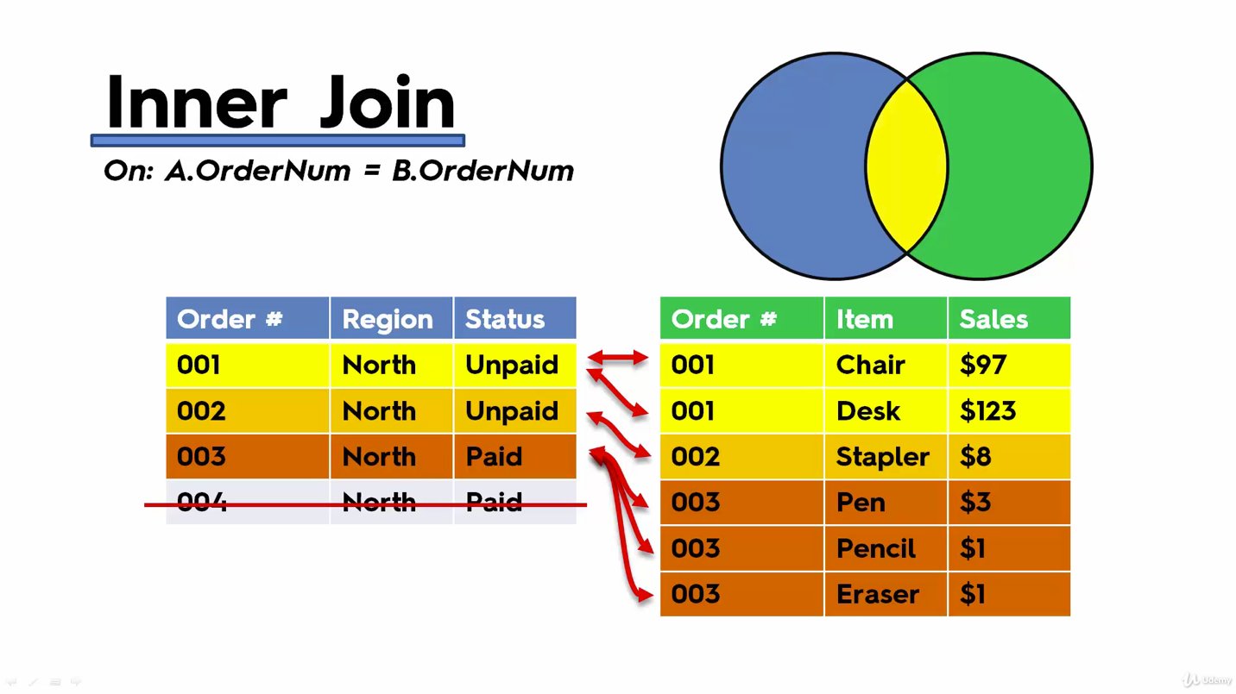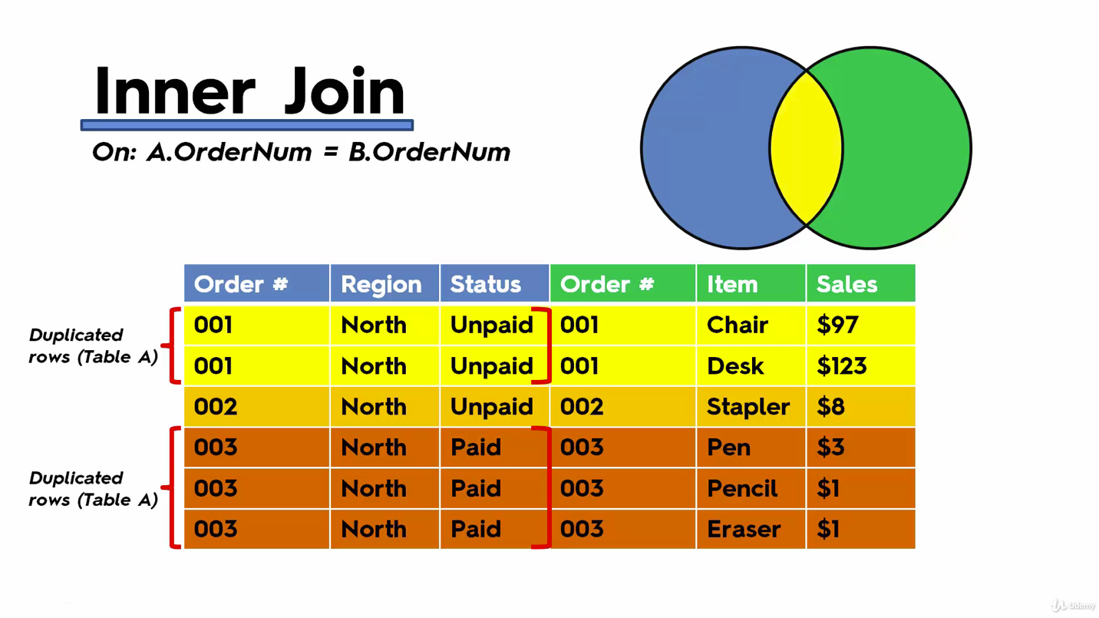

***Joining on multiple fields***

If you join on single field:

- Rows will be duplicated without an actual reason

- Hyper-inflation of measures

- Incorrect insights and business decisions

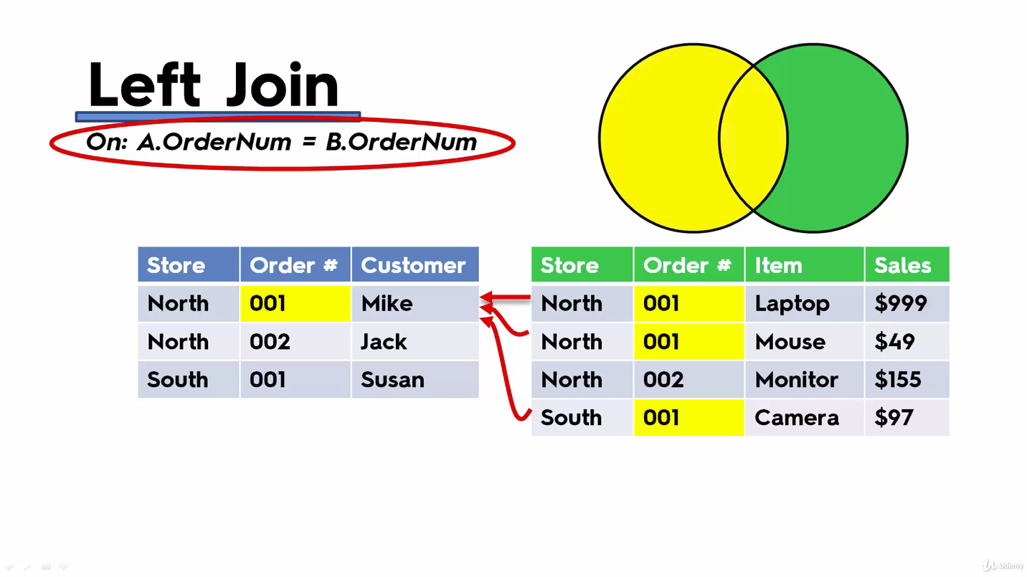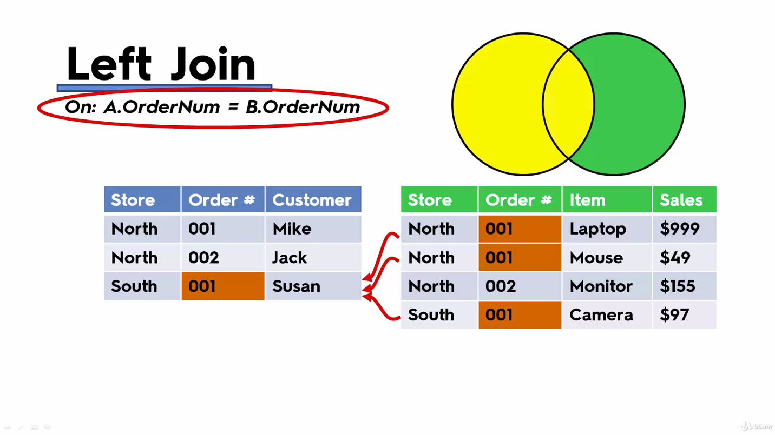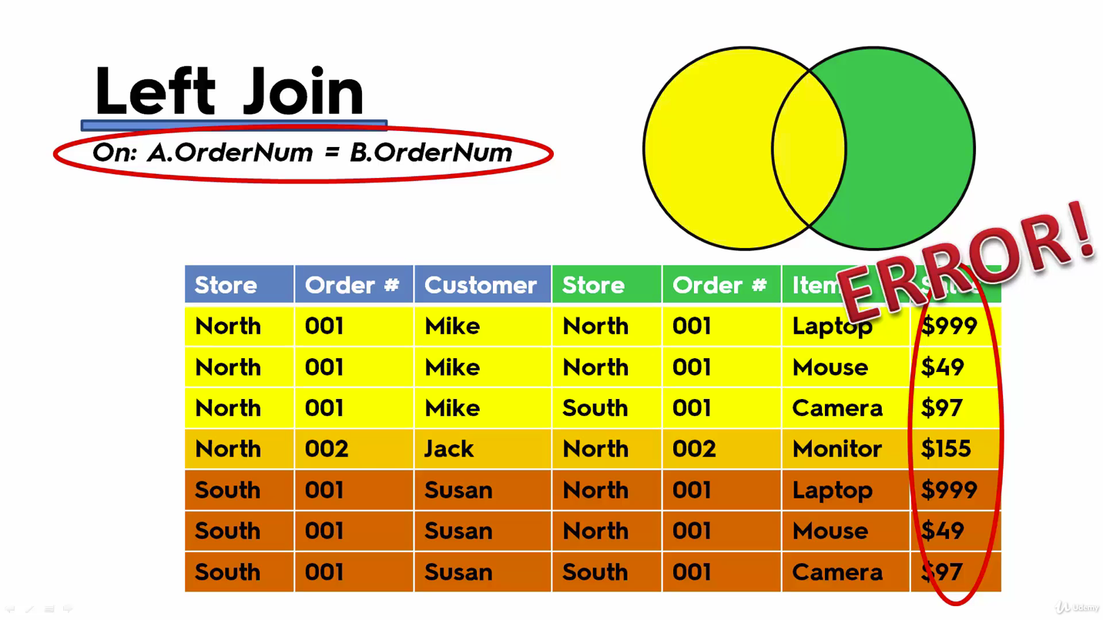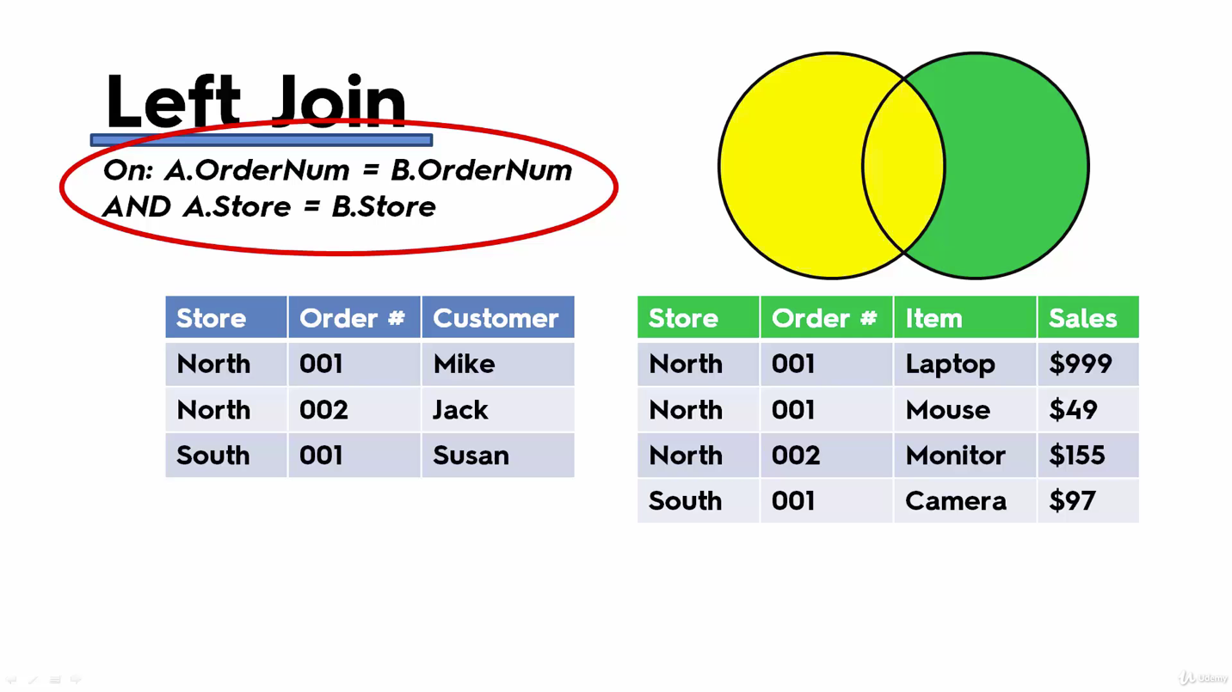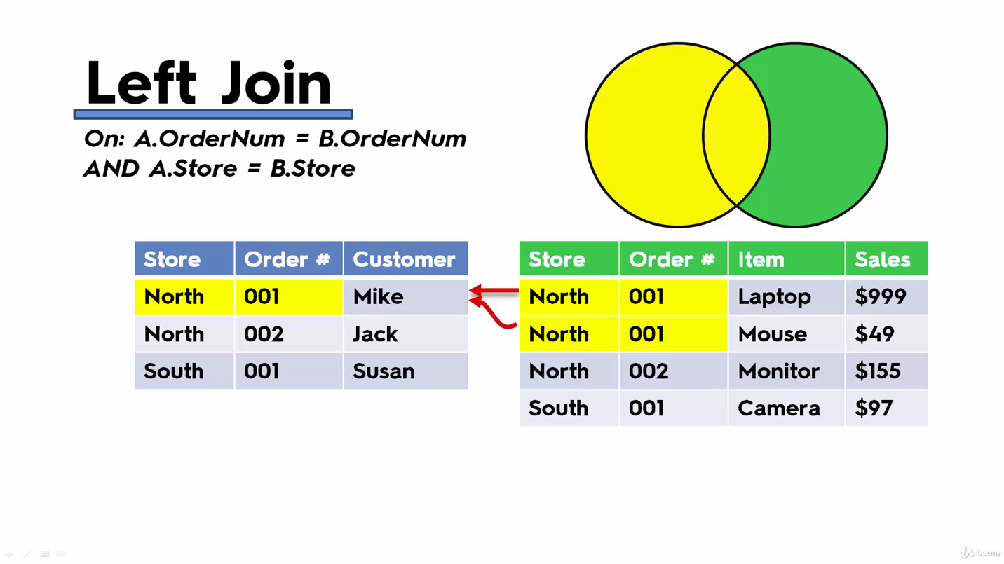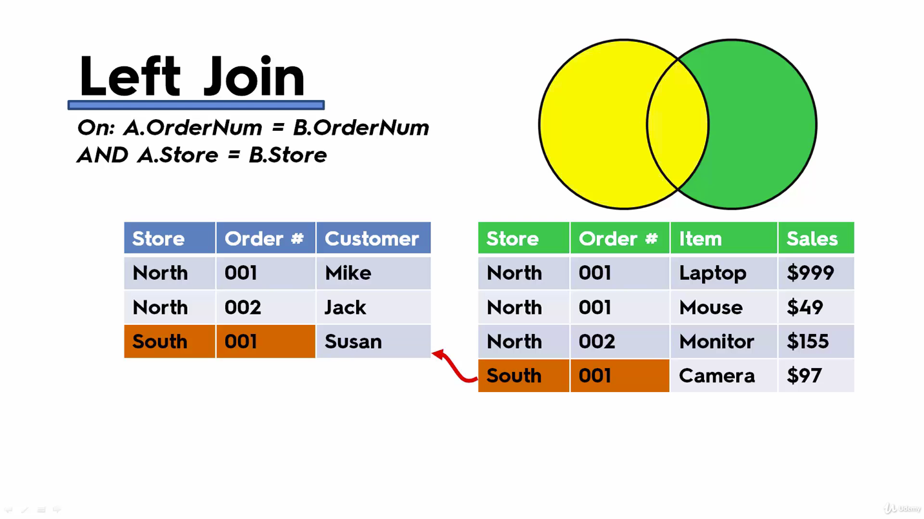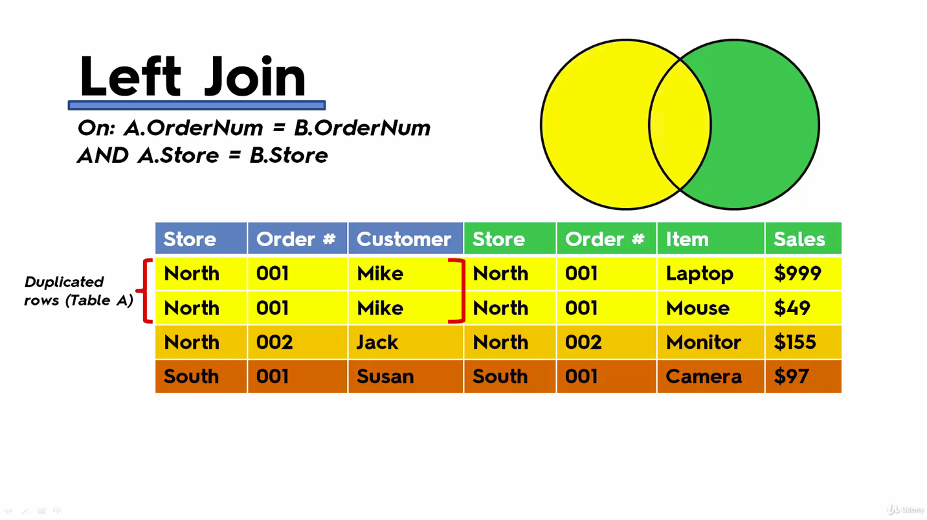

***Blending Data***

A blend is like a smart join ‘on the fly’

It’s a left join

Common fields with the same name are picked up automatically as the blend clause

You can control this via the ‘Data’ menu

Blending occurs at the granularity of your view

Aggregation happens before the blend

Blending happens after aggregation is performed on the separate datasets

Blends are unique to each worksheet

When joins don’t work

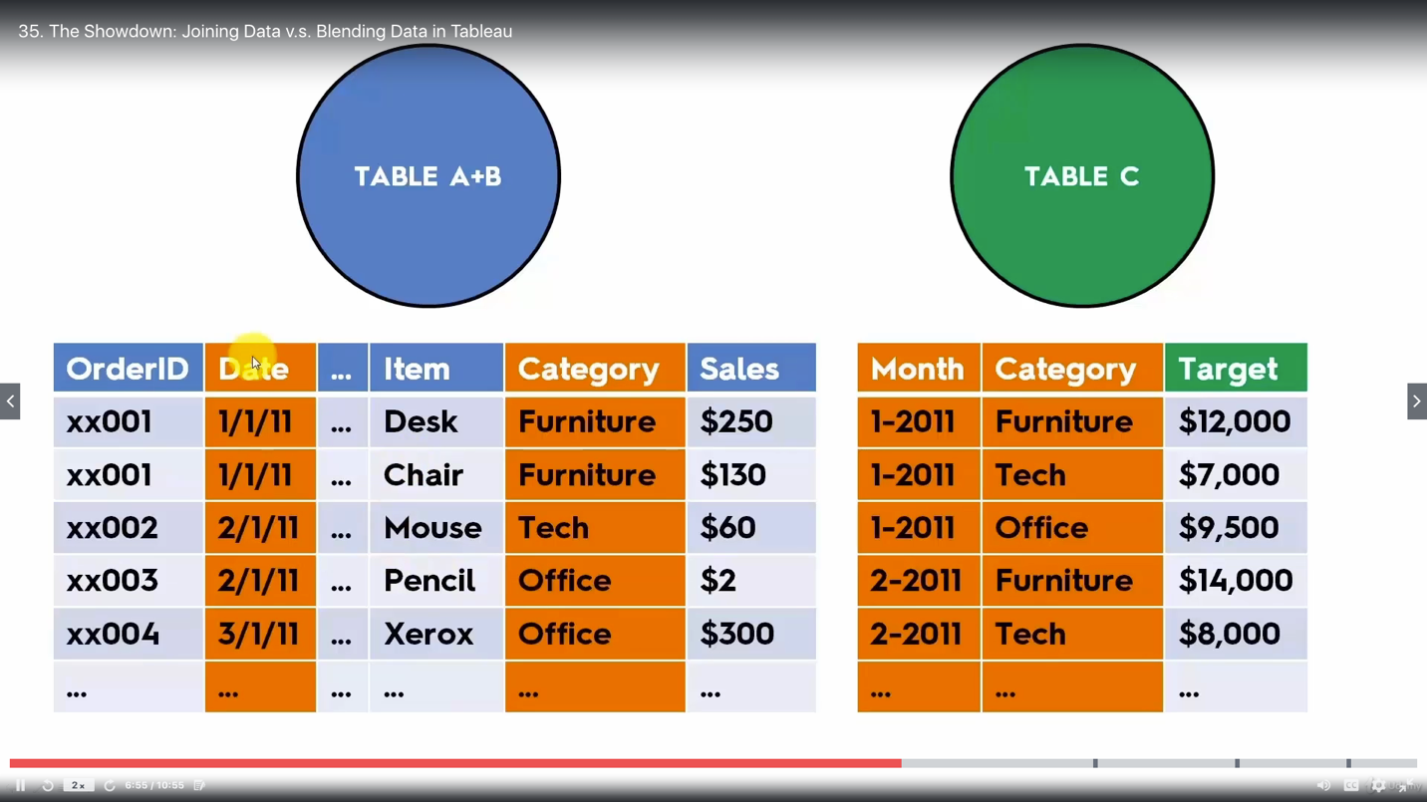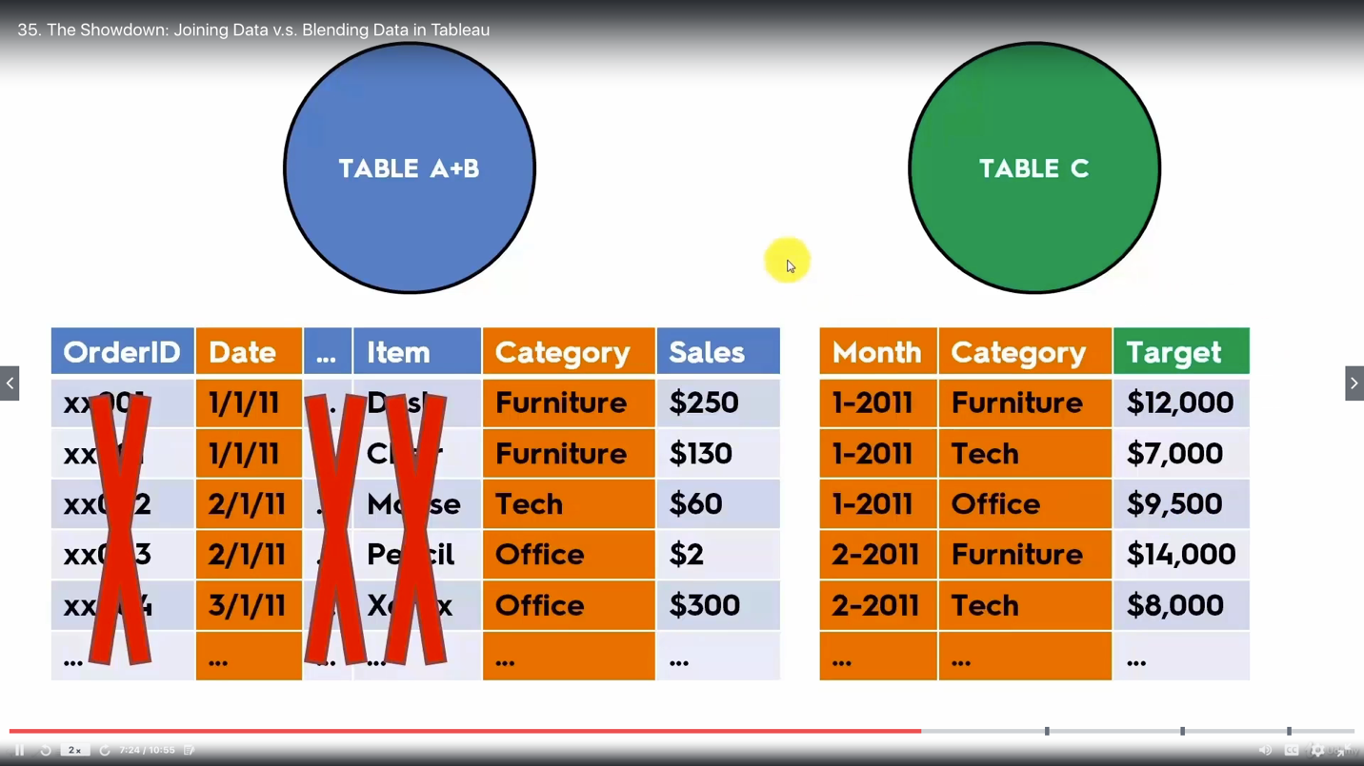

***Example for blending***

Add data from different sources

Relation

Connect to P1-Airline-Comparison

Drag Airline1 to view

Connect to P1-Airline-Comparison again

Drag Airline2 to view (Airline1 in view)

Edit Relationship

Region - Region

Period - Year

Blend

Connect to P1-Airline-Comparison

Drag Airline1 to view

Data - New Data Source - Connect to P1-Airline-Comparison

Drag Airline2 to view (empty)

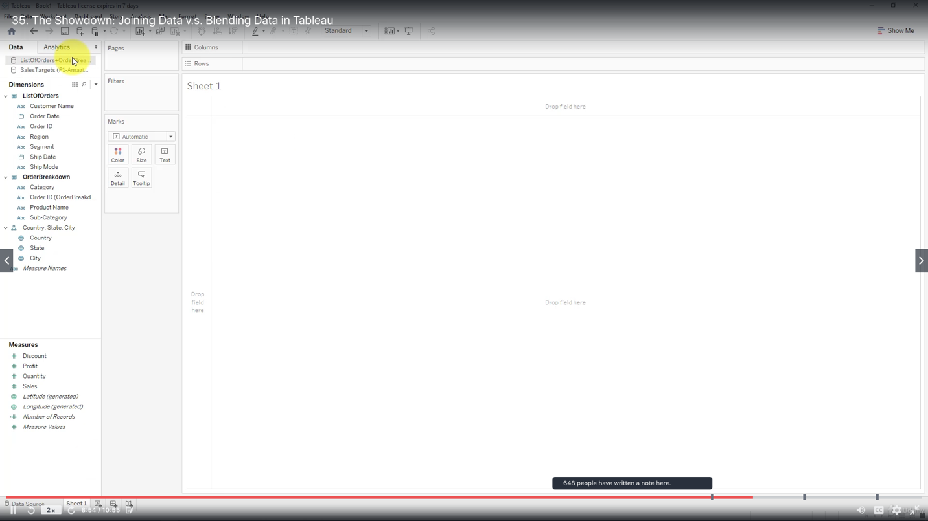

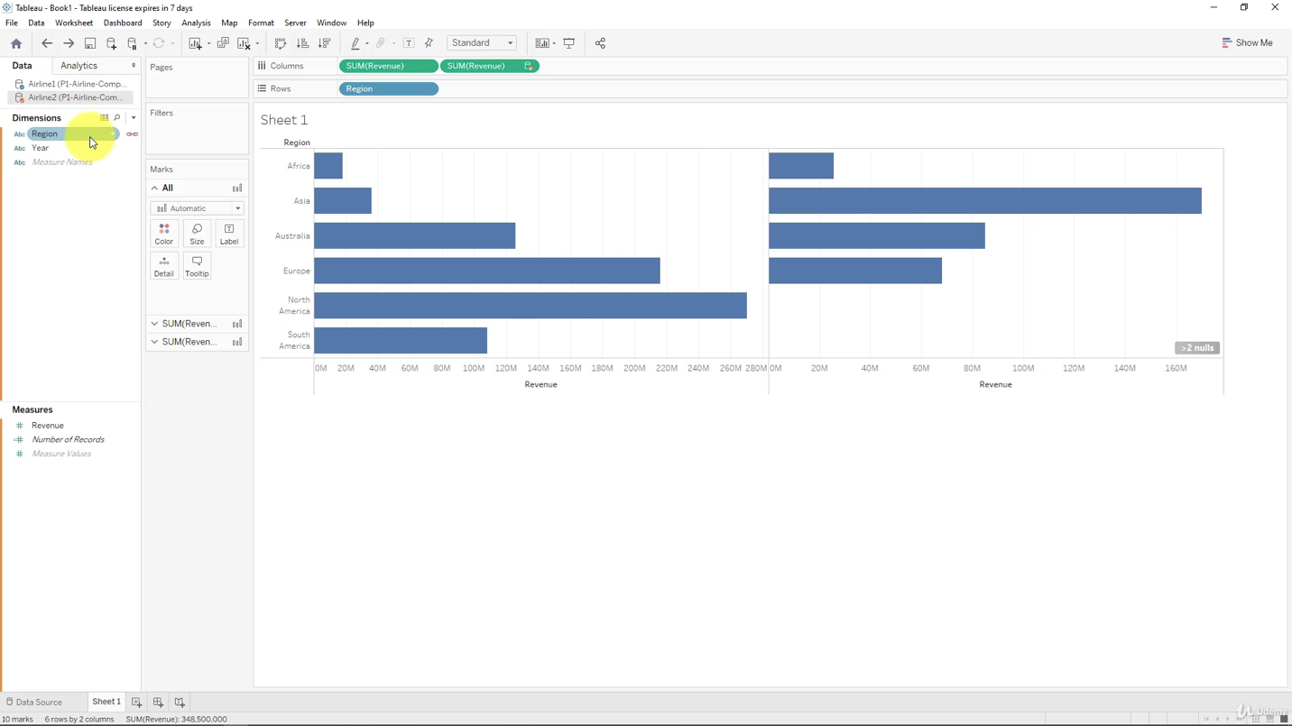

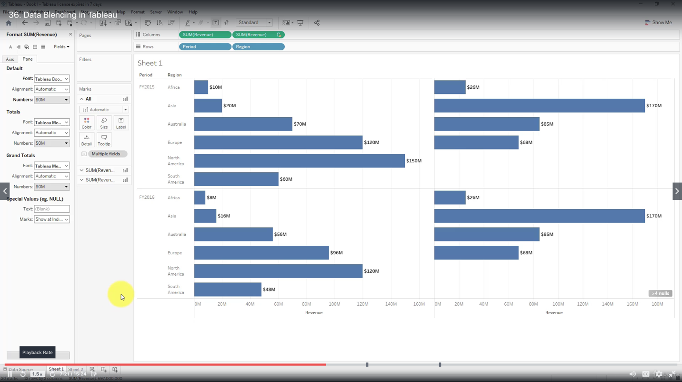

Something went wrong, (the results on the right is aggregated over the years)

you need to edit blend relationships

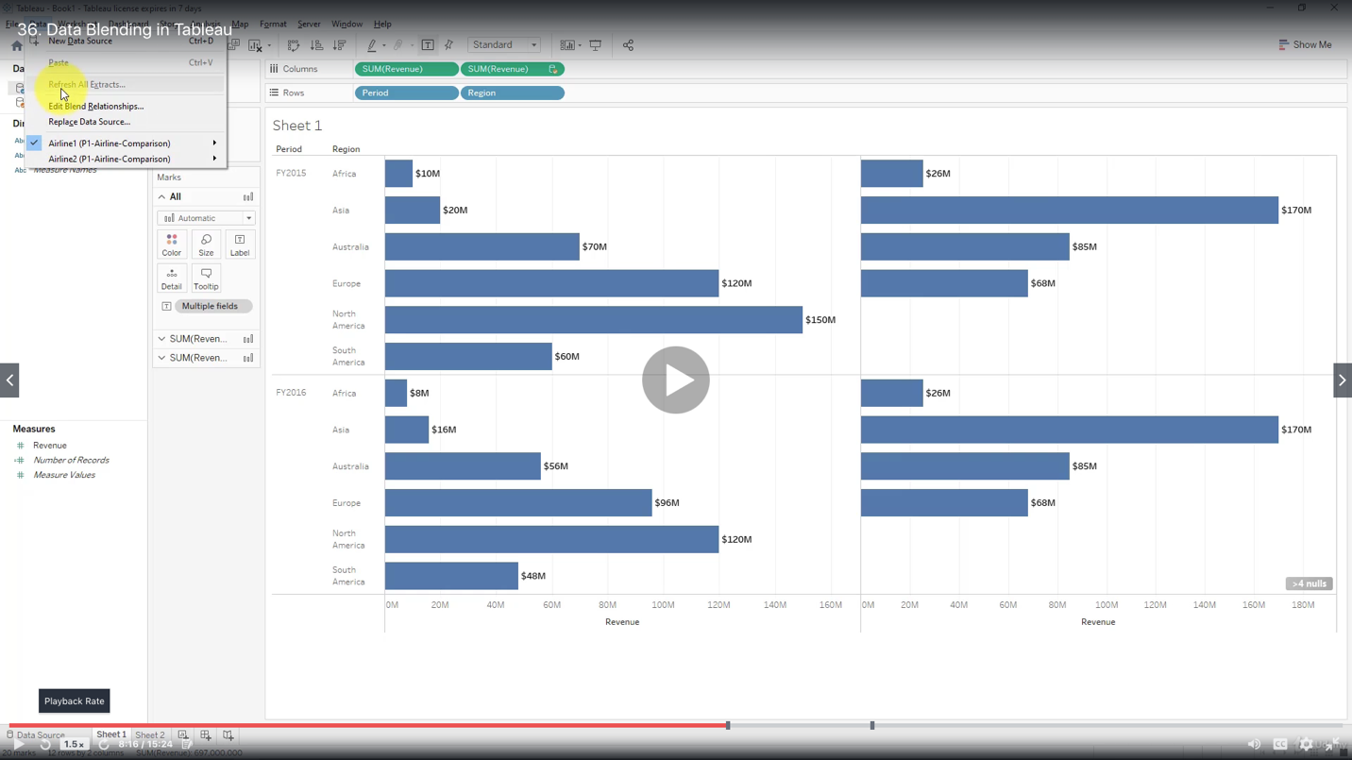

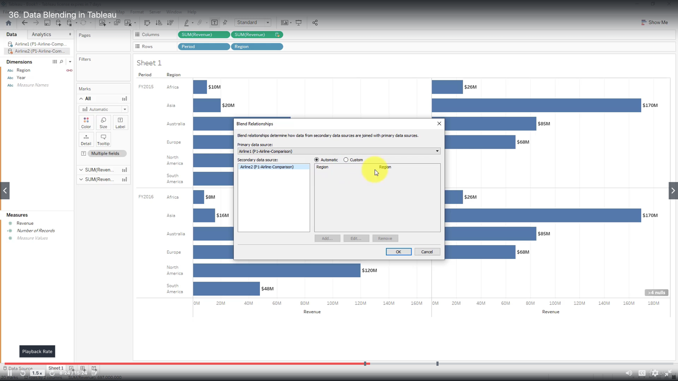

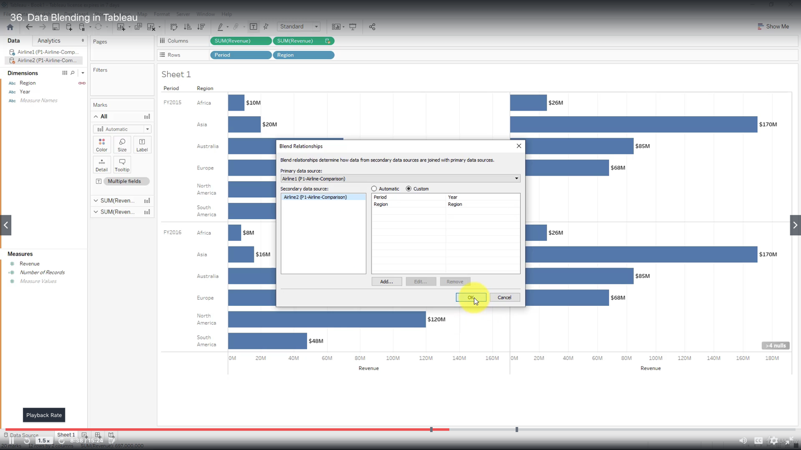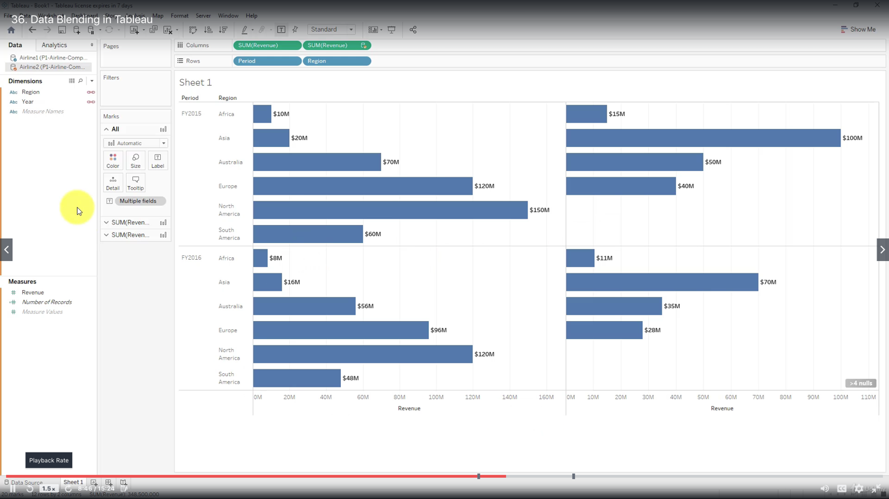

You may change your primary source and things become different.

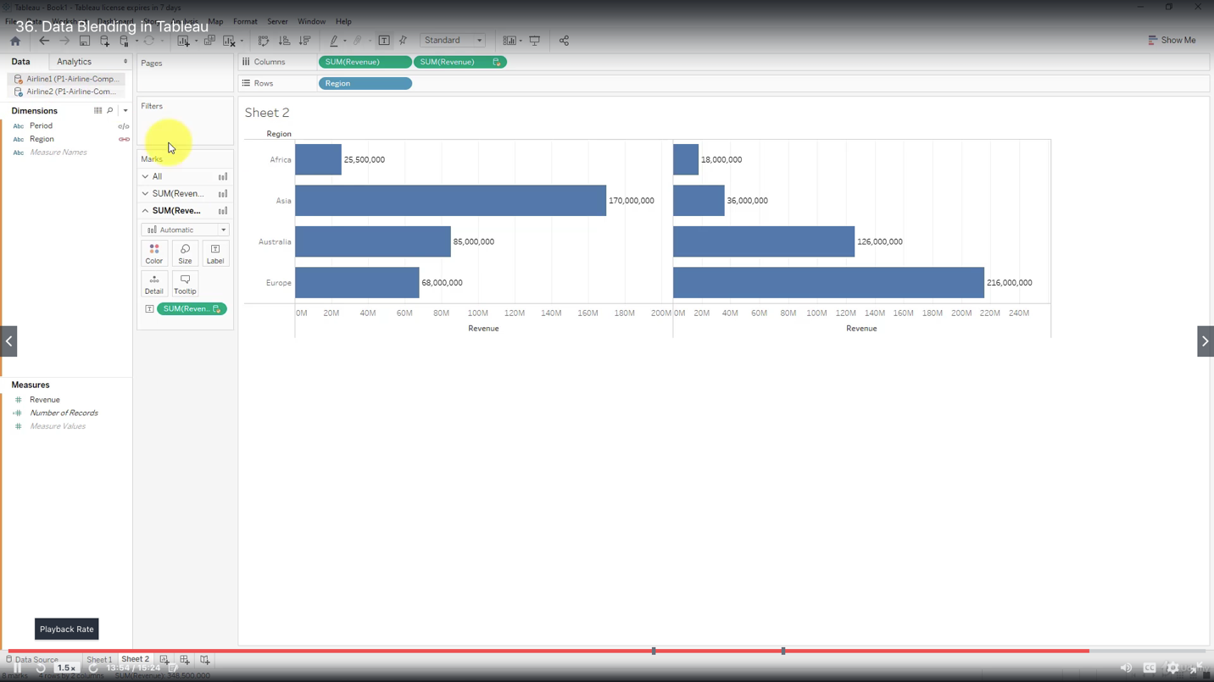

***Joining vs Blending***

Use Joins when:

Combine data at row level

Use Blends when:

Data sources have different levels of granularity

Data sources come from different systems

Simply cannot do a join for any other reason

***Dual Axis Chart***

Join

Connect to AmazingMArtEU2

Drag ListOfOrders to view

Click on ListOfOrders

Drag OrderBreakDown (inner join)

Blend

Data - New Data Source - Connect to AmazingMArtEU2

Drag SalesTargets to view (empty)

Drag Airline2 to view

Data - Edit Blend Relationships

Custom

(Already exists: category - category)

- Add

Primary data source field - Order Date - Month( Order Date)

Secondary data source field - Month of Order Date - Month (Month of Order date)

Since Month is a categorical variable

- Add

Primary data source field - Order Date - Year (Order Date)

Secondary data source field - Month of Order Date - Year (Month of Order date)

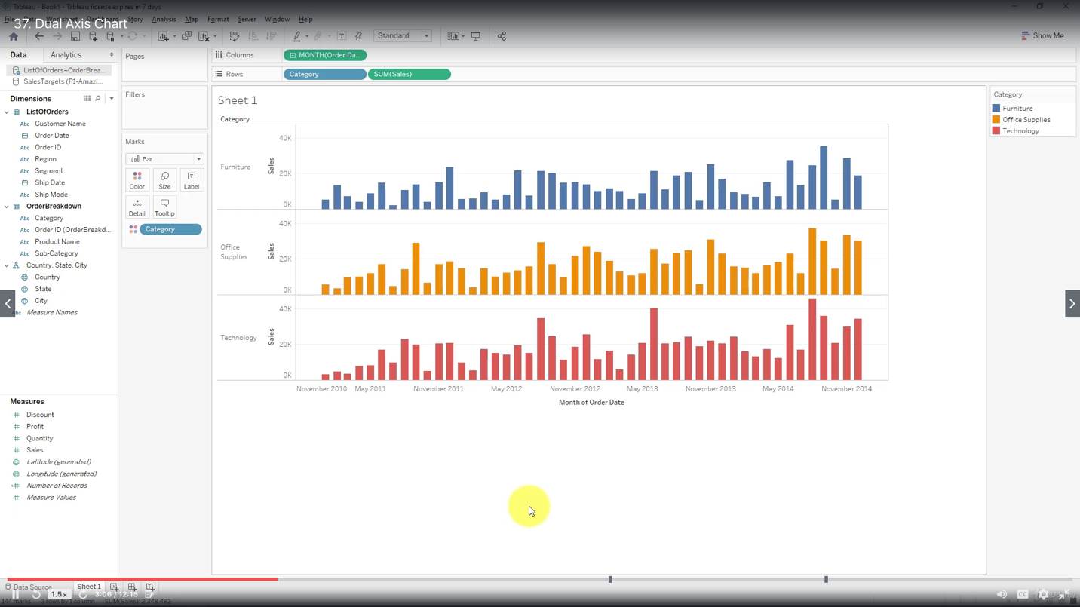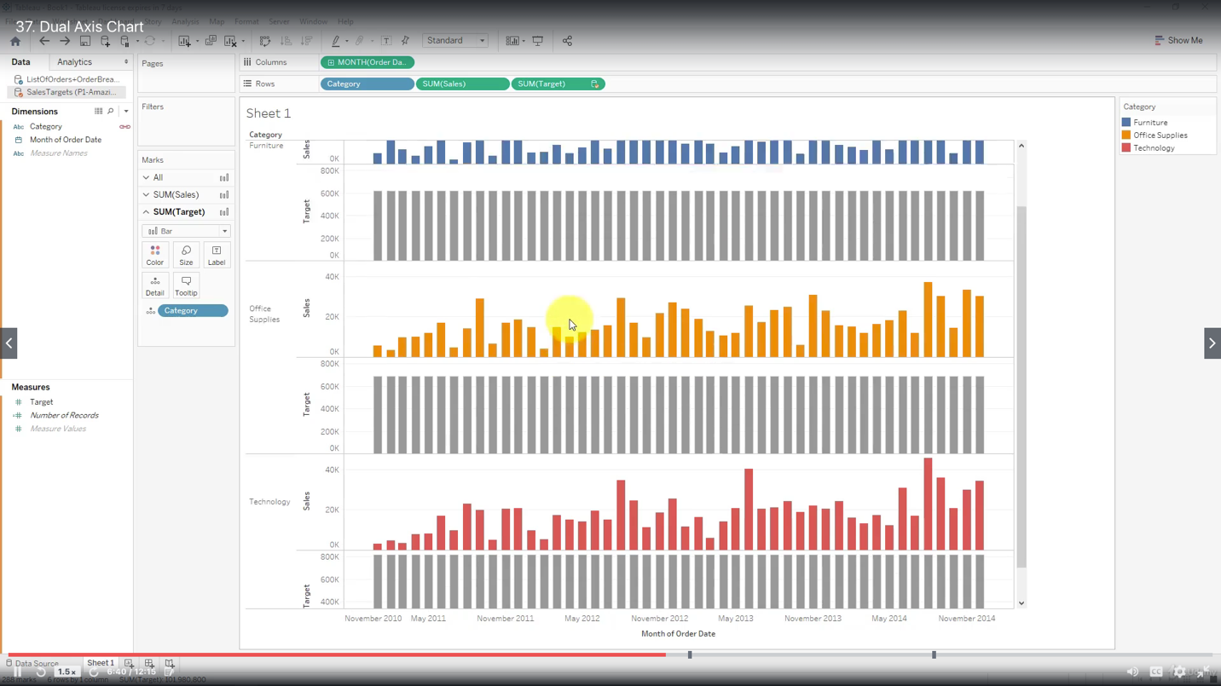

Edit blend relationships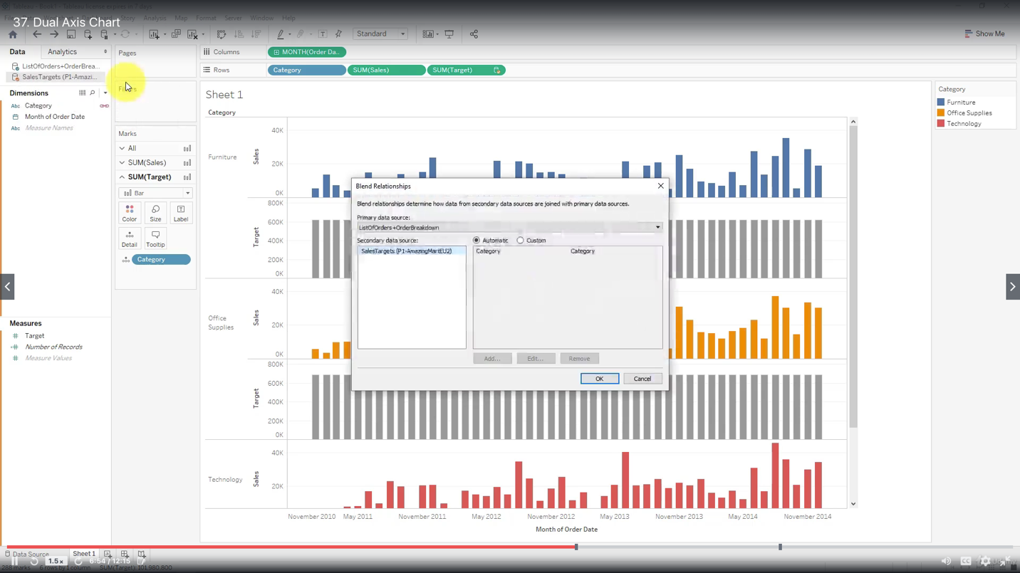

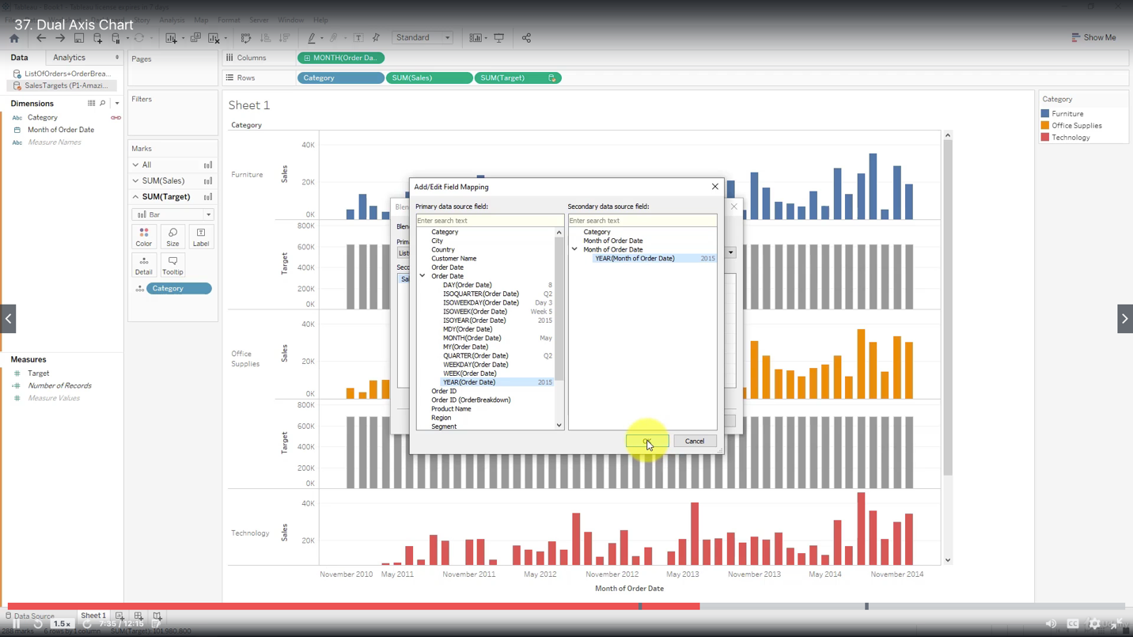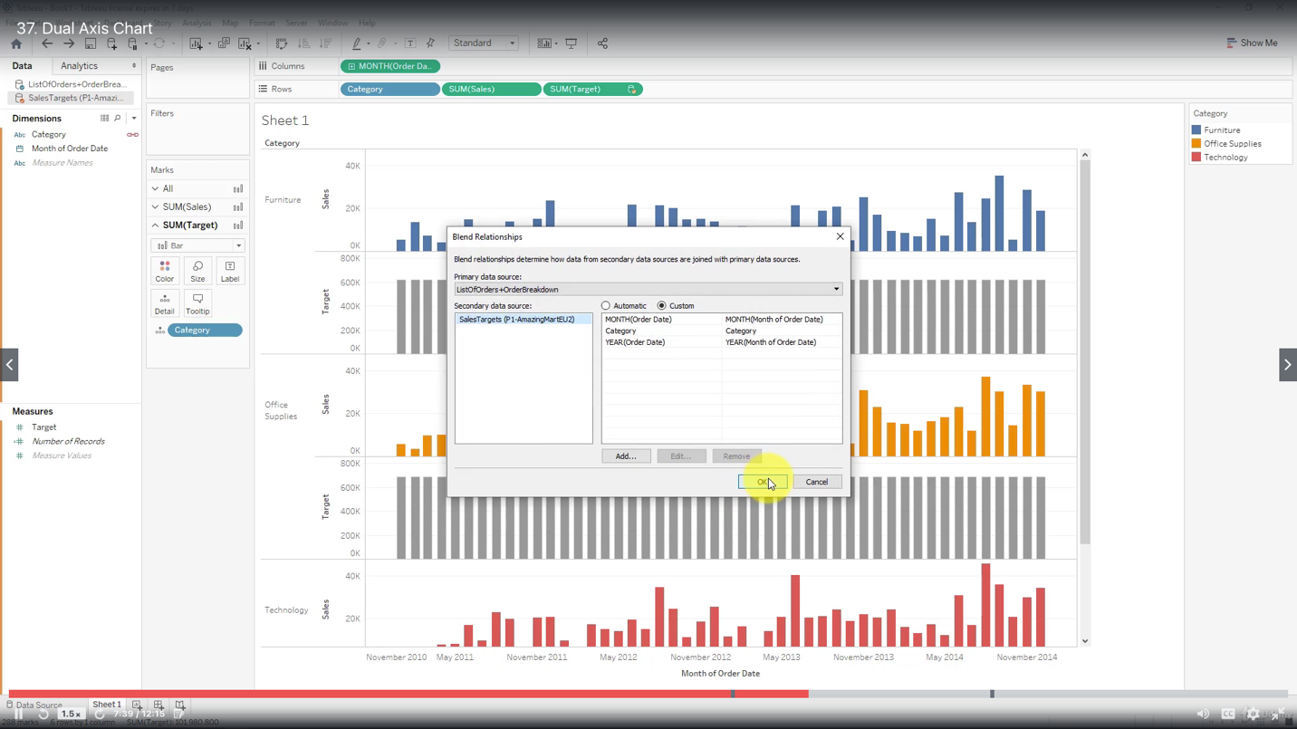

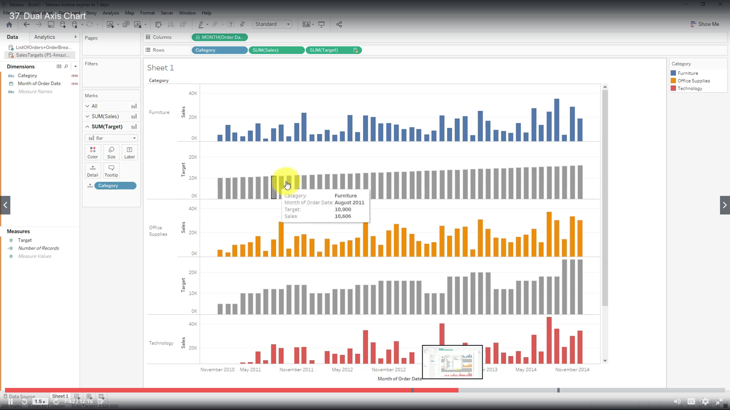

Change to area

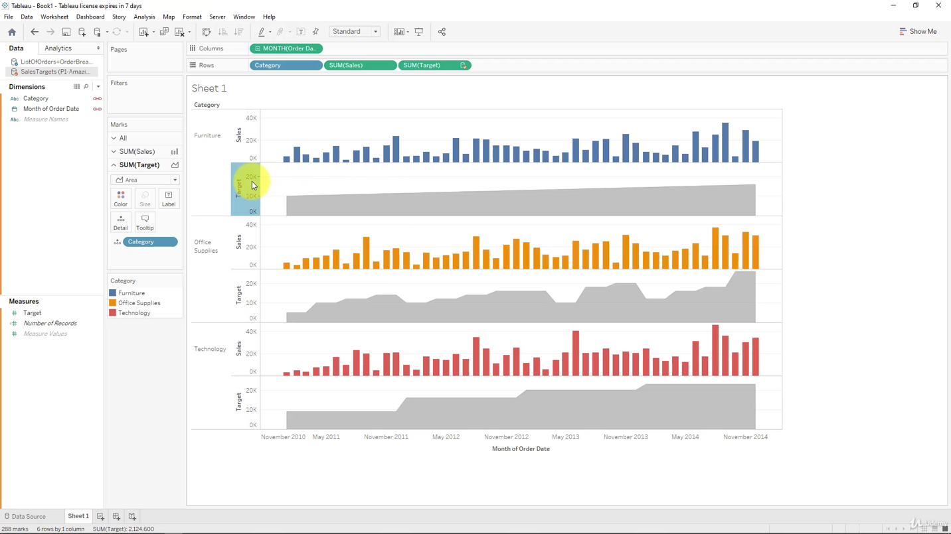

Make dual axis

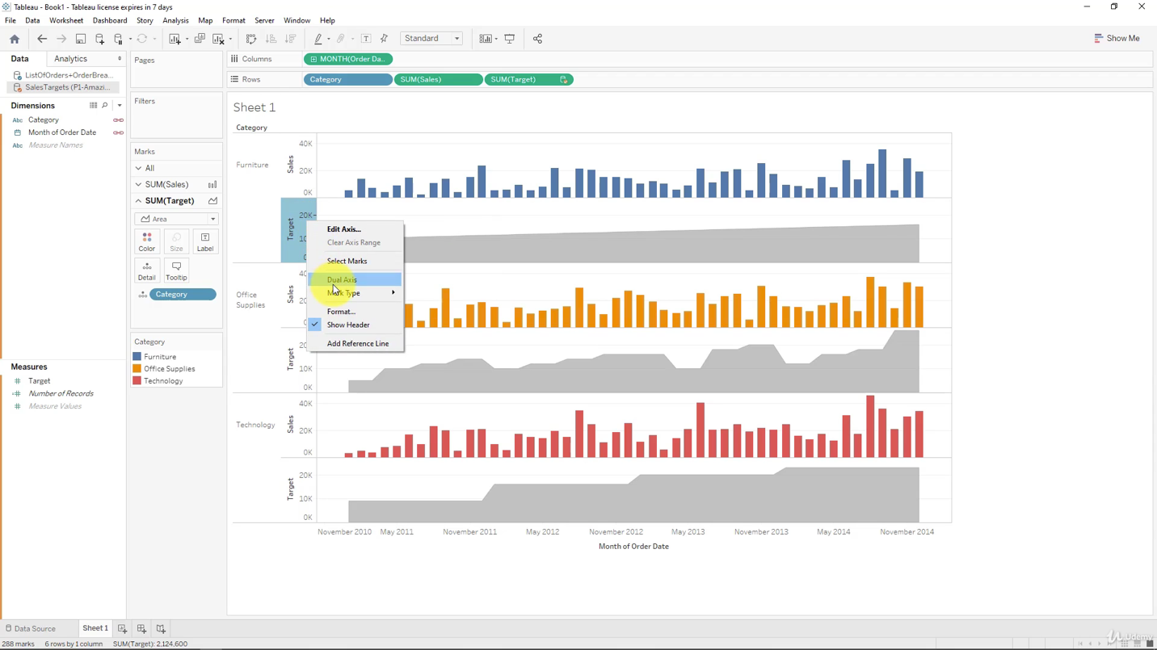

Don’t forget to synchronize the axis

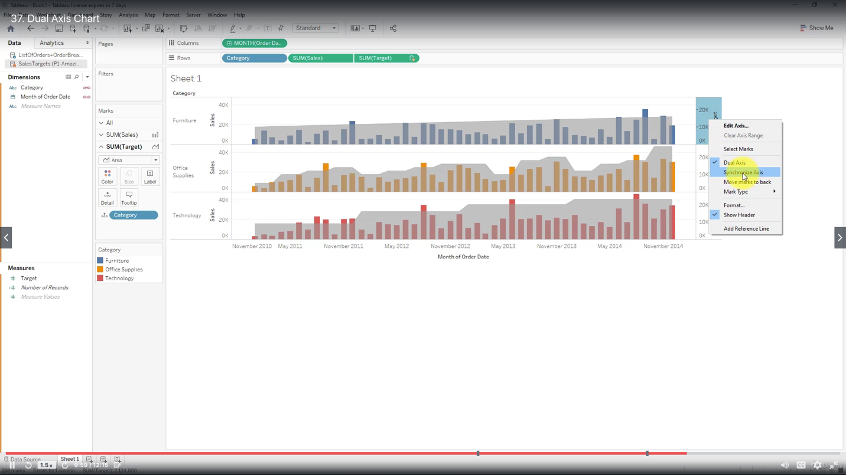

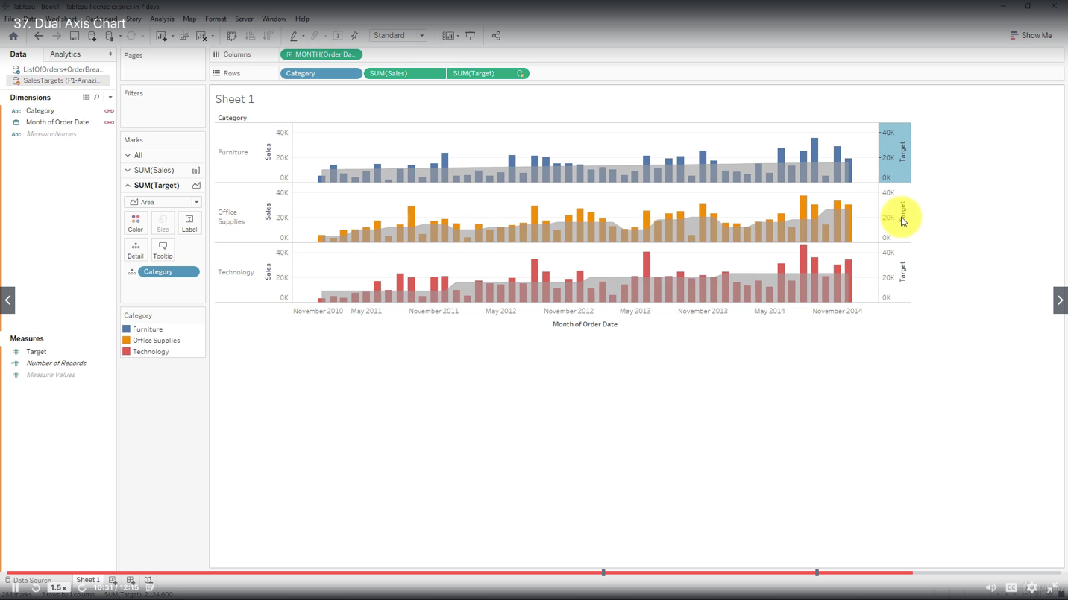

Adjust the order of rows to move charts backwards and forwards as required

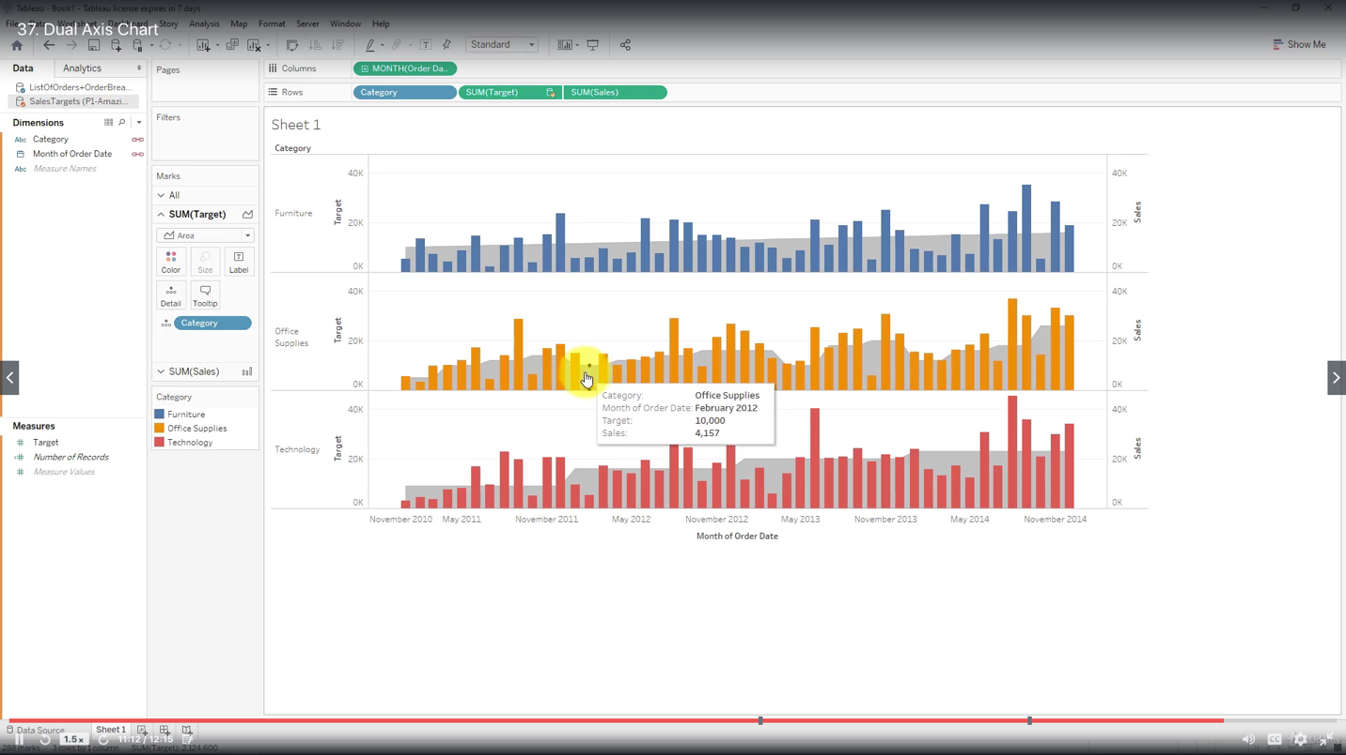

Create calculated fields in blend

The data elements used have to be aggregated

Values are aggregated due to the nature of the blend

